

## **CHAPTER NO 3**

# **FINITE DIFFERENCES**

## **INTRODUCTION**

Numerical Analysis is a branch of mathematics which leads to approximate solution by repeated application of four basic operations of Algebra. The knowledge of finite differences is essential for the study of Numerical Analysis. In this section we introduce few basic operators.

## **FORWARD DIFFERENCE OPERATOR**

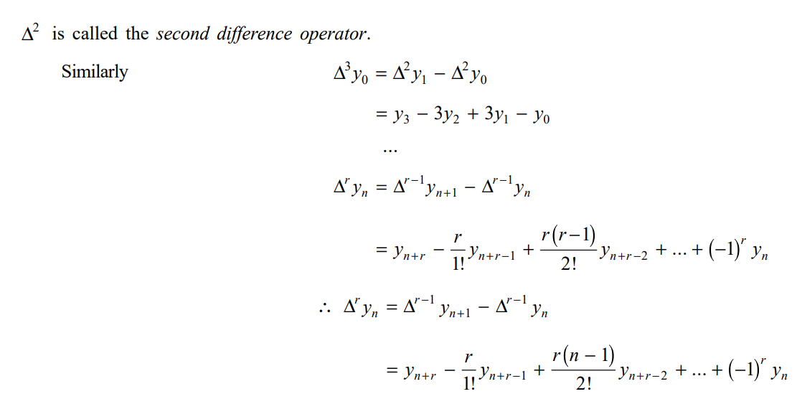

## **Difference Table**

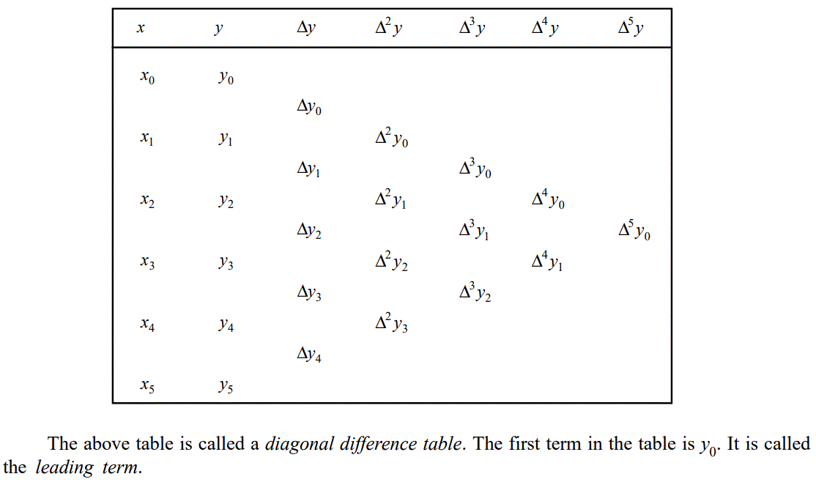It is a convenient method for displaying the successive differences of a function. The following table is an example to show how the differences are formed.

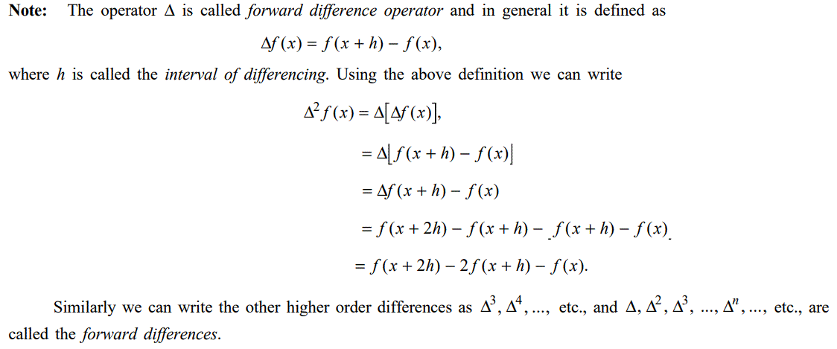A convenient check may be obtained by noting the sum of the entries in any column equals the differences between the first and the last entries in preceding column.

## **Properties of the Operator ∆**

## 

## **THE OPERATOR E**

## **Relation between the Operator E and ∆**

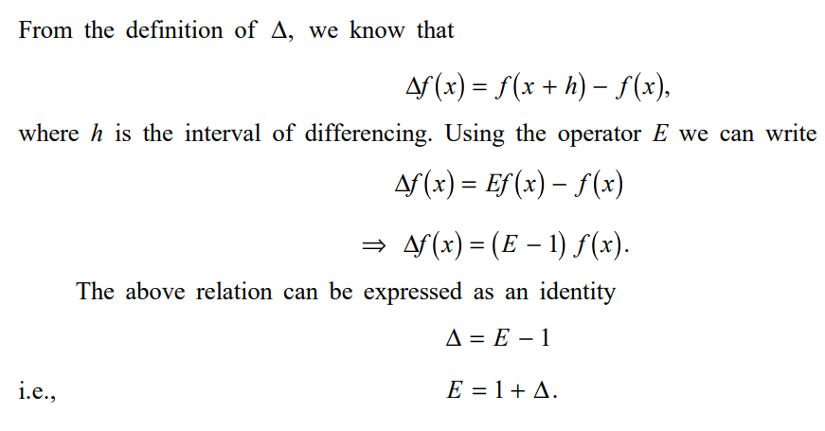

## **E∆ ≡ ∆E**

**PROOF**

## **BACKWARD DIFFERENCES**

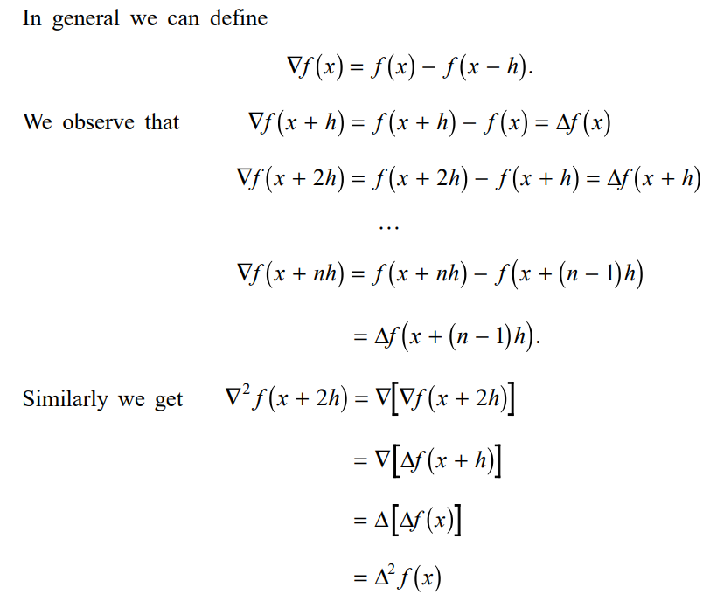



## **Relation between E and ∇:**

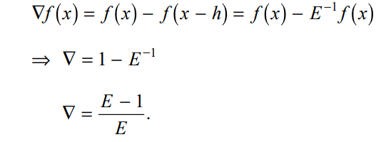

**PROOFS**:

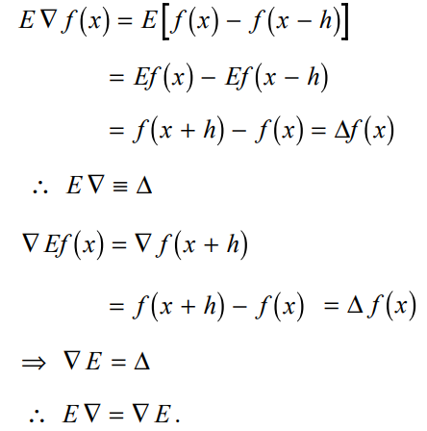

**Note: From the above it is clear that operators E and ∇ commute and ∆, ∇, δ, E and µ also commute.**